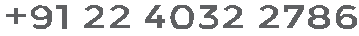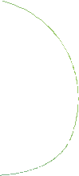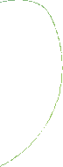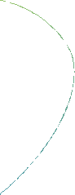

LIST OF AUTHORIZED SIGNATORIES

The details of Authorised signatory of the Company, Sarla Performance Fibers Limited are as follows:

Sr. No. | Name | Designation | Photograph | Specimen Signature with stamp/sign
1. | Mr. Krishnakumar Jhunjhunwala | Managing Director
2. | Vrinda Krishna Jhunjhunwala | Authorised Signatories

For Sarla Performance Fibers Limited

(Krishnakumar Jhunjhunwala) (Vrinda Krishna Jhunjhunwala)
Managing Director Authorized Signatory
DIN: 00097175

